**Release and Sprint Plans**

**Team Number 2**

|  |  |
| --- | --- |
| Student Number | Team Member Name |
| ***n9703438*** | Harrison Ryan |
| ***n9493603*** | Jack Henderson |
| ***n10112979*** | Hoang Anh Pham |
| ***n9510940*** | Nicholas Toumbas |
| ***n9840311*** | Mingtai Yang |

Tutor: TARA

Version: 2.0

Date: 21/03/18

**Table of Contents**

**Release 1** **3**

Initial Website 3

Create Account 3

Contract 4

Editable Database 4

**Release 2** **4**

Admin, Teacher and Student Account Creation and Login 4

View Timetable 5

Instrument Availability 5

Lesson Request 6

**Release 3** **6**

Booking Instrument 6

Notes and Feedback 6

Reports 7

**Delivery Schedule** **8**

**Sprint 1** **10**

Story ID 1: Accessing the Website 10

Story ID 2: Create Student Account (admin) 10

Story ID 3: Create Teacher Account(admin) 10

Story ID 5: Create Contracts 11

Release Plan

# Release 1

**Delivery date: 30/05/18** **Total Story Points: 20**

Present a initial website in which students and teachers can interact with to see music lessons and contracts. Administrators will be able to edit and maintain databases as well as create contracts between teachers and students. This release is to ensure initial value to the client without over-development.

## Initial Website

By creating a website this provides immediate benefit for the business as the user functions are able to be initiated. Building this is important as it is the basis for the rest of the project.

|  |  |  |
| --- | --- | --- |
| Story ID | Story Title | Story Points |
| SI1 | Access the Website | 4 |
|  | Story Point Sub-Total: | 4 |

## Create Account

Creating an account is important to the initial release as a teacher and student account is needed to create a contract between the two. By having this available, contracts can be created and therefore delivers value for the business.

|  |  |  |
| --- | --- | --- |
| Story ID | Story Title | Story Points |
| SI2 | Create Student Account (Admin) | 2 |
| SI3 | Create Teacher Account (Admin) | 2 |
| SI7 | Admin Login (Admin) | 2 |
|  | Story Point Sub-Total: | 6 |

## 

## Contract

Contract is a must in the initial website because it’s the significant function to produce/generate business value. The admin is able to create and terminate contracts.

|  |  |  |
| --- | --- | --- |
| Story ID | Story Title | Story Points |
| SI5 | Create Contracts | 4 |
| SI6 | Terminate Contracts | 2 |
|  | Story Point Sub-Total: | 6 |

## Editable Database

An editable database in which the student and teachers details are kept is important. This is because if anyone's details change they needed to be edited.

|  |  |  |
| --- | --- | --- |
| Story ID | Story Title | Story Points |
| SI8 | View Database | 2 |
| SI9 | Edit Database | 2 |
|  | Story Point Sub-Total: | 4 |

## 

# Release 2

**Delivery date: 27/06/18** **Total Story Points: 26**

Release a more detailed website in which students and teachers can create profiles on. Teachers and students will be able to login to the website. Basic instrument availability outline will be displayed.

## Admin, Teacher and Student Account Creation and Login

Teachers and students are able to create accounts for themselves. Using these accounts they are able to login to the website. This provides business use as each user is able to create an account in which they can use. More administrator accounts need to be also available for creation as this may be necessary as a business function.

|  |  |  |
| --- | --- | --- |
| Story ID | Story Title | Story Points |
| SI14 | Login(student) | 2 |
| SI15 | Login (teacher) | 2 |
| SI12 | Create Account (student) | 4 |
| SI13 | Create Administrator Account(Administrator) | 2 |
|  | Story Point Sub-Total: | 10 |

## View Timetable

Teachers and students are able to view each of their timetables graphically. This will allow them to see their lessons for each week with the time and location. This is valuable to a business as it makes it easier for the users to participate in lesson viewing.

|  |  |  |
| --- | --- | --- |
| Story ID | Story Title | Story Points |
| SI10 | List Times (Student) | 4 |
| SI11 | List Times (Teacher) | 4 |
|  | Story Point Sub-Total: | 8 |

## Instrument Availability

By showing instrument availability to each user it provides moderate value to the business. As a student knowing when instruments are available is important as they want to use them for lessons. This helps to generate revenue for the business as they can hire instruments.

|  |  |  |
| --- | --- | --- |
| Story ID | Story Title | Story Points |
| SI20 | Instrument Inventory (Student) | 1 |
| SI22 | Instrument Inventory (Staff) | 1 |
|  | Story Point Sub-Total: | 2 |

## Lesson Request

Making lesson requests with a preference for a teacher can be a major benefit for the students. This adds to the business as students can get more continuity out of lessons.

|  |  |  |
| --- | --- | --- |
| Story ID | Story Title | Story Points |
| SI4 | Lesson Request | 4 |
| SI19 | Continuity | 2 |
|  | Story Point Sub-Total: | 6 |

## 

# Release 3

**Delivery date: 25/07/18** **Total Story Points: 26**

## Booking Instrument

The instrument booking system is a major component of how students and teachers would hire instruments. By setting up this system online, this helps to reduce the paperwork required for the music school, will provide value by saving time spent filling forms and, consequently, save money.

|  |  |  |
| --- | --- | --- |
| Story ID | Story Title | Story Points |
| SI17 | Instrument Booking | 4 |
|  | Story Point Sub-Total: | 4 |

## 

## Notes and Feedback

Notes and feedback are a valuable tools for any business to have. Not only will this system provide value by allowing teacher notes to be added, and allowing student feedback on teachers to be tracked, but it will also enable note tracking on students -- enabling the music school to digitally track students to allow a more personalised teaching experience across multiple teachers.

|  |  |  |
| --- | --- | --- |
| Story ID | Story Title | Story Points |
| SI18 | Notes (Teacher) | 2 |
| SI23 | Feedback (Student) | 2 |
| SI27 | Notes (Administrator) | 2 |
|  | Story Point Sub-Total: | 6 |

## Reports

The reports generated for the administrator are necessary as they will help them to evaluate their current business standings. By allowing reports to be generated this will provide value to the administrators as they may need to see which teachers are available to teach instruments or see their feedback.

|  |  |  |
| --- | --- | --- |
| Story ID | Story Title | Story Points |
| SI16 | “Currently Teaching” Report | 4 |
| SI25 | Create a Report | 8 |
| SI26 | Feedback Report | 2 |
|  | Story Point Sub-Total: | 14 |

## 

**Contact**Teachers need to be able to contact the owner through the website as this will help them set up an interview and find the owner. An email form will be generated on the website in which sends to the owner. This provides business value as new teachers can contact the owner easier.

|  |  |  |
| --- | --- | --- |
| Story ID | Story Title | Story Points |
| SI24 | Contact Owner (Prospective teacher) | 2 |
|  | Story Point Sub-Total: | 2 |

## 

# Delivery Schedule

|  |  |  |  |  |  |  |  |
| --- | --- | --- | --- | --- | --- | --- | --- |
| Week 6 | Week 7 | Week 8 | Week 9 | Week 10 | Week 11 | Week 12 | Week 13 |
| W/C 26/03 | W/C 16/04 | W/C 23/04 | W/C 30/04 | W/C 07/05 | W/C 14/05 | W/C 21/05 | W/C 28/05 |
| Sprint 1 | | | | Sprint 2 | | | |
| Release 1 | | | | Release 1 | | | |

|  |  |  |  |  |  |  |  |
| --- | --- | --- | --- | --- | --- | --- | --- |
| Week 14 | Week 15 | Week 16 | Week 17 | Week 18 | Week 19 | Week 20 | Week 21 |
| W/C 04/06 | W/C 11/06 | W/C 18/06 | W/C 25/06 | W/C 02/07 | W/C 09/07 | W/C 16/07 | W/C 23/07 |
| Sprint 3 | | | | Sprint 4 | | Sprint 5 | |
| Release 2 | | | | Release 3 | | | |

Estimated Velocity: 9

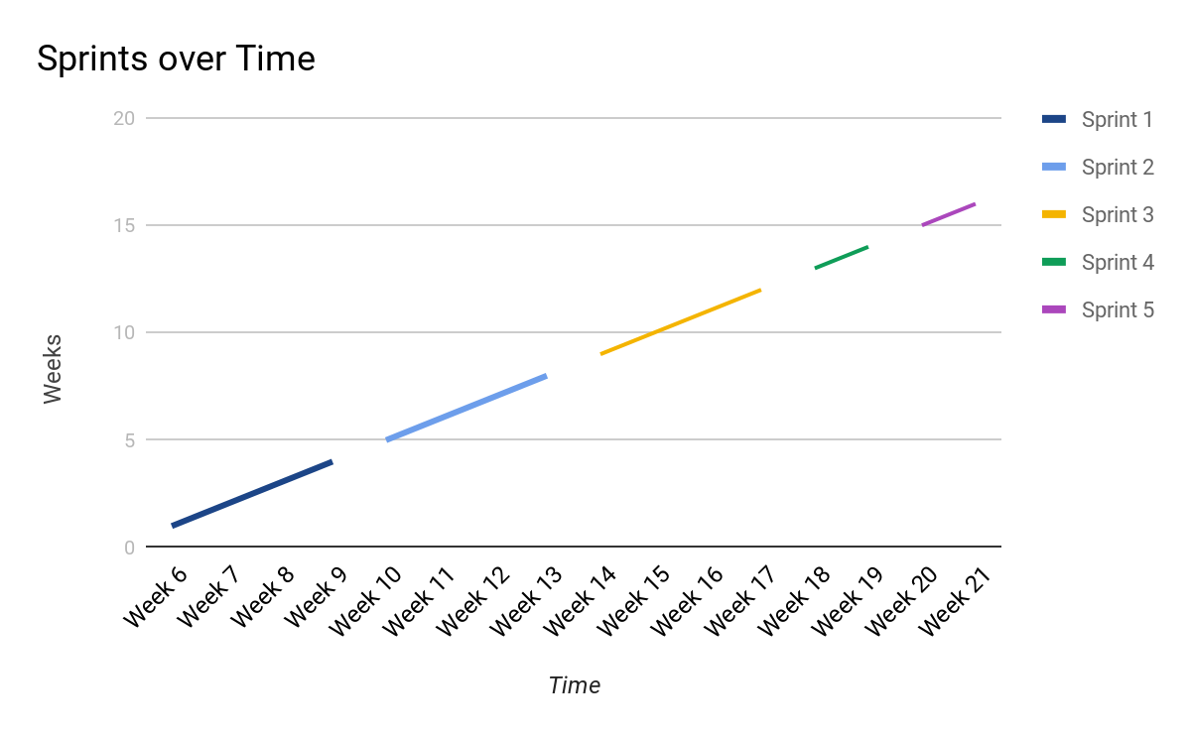

Sprint Plan

# Sprint 1

Total Story Points: 12 Total Estimated Hours: 34

Current Velocity: <nil> Total Hours Taken: <nil>

## Story ID 1: Accessing the Website

|  |  |  |  |
| --- | --- | --- | --- |
| Task ID | Task Description | Estimate | Taken |
| T01 | Initialise blank server and web-page, accessible via internet | 2 |  |
| T02 | Create welcome page for server | 1 |  |
| T03 | Create menu buttons for welcome page | 2 |  |
| T04 | Add logo to website | 1 |  |
|  | Story Points: 4 Total Hours: | 6 |  |

## Story ID 2: Create Student Account (admin)

|  |  |  |  |
| --- | --- | --- | --- |
| Task ID | Task Description | Estimate | Taken |
| T05 | Create fields that link to database | 4 |  |
| T06 | Make a create button that takes field and applies them | 1 |  |
|  | Story Points: 2 Total Hours: | 5 |  |

## Story ID 3: Create Teacher Account(admin)

|  |  |  |  |
| --- | --- | --- | --- |
| Task ID | Task Description | Estimate | Taken |
| T07 | Create different field identifier (separates student from teacher) | 2 |  |
| T08 | Create button that applies filled fields to database | 2 |  |
|  | Story Points: 2 Total Hours: | 4 |  |

## Story ID 5: Create Contracts

|  |  |  |  |
| --- | --- | --- | --- |
| Task ID | Task Description | Estimate | Taken |
| T09 | Make students and teachers viewable graphically | 6 |  |
| T10 | Create button that can open a new form | 3 |  |
| T11 | Create fields in which allow creation of contract between student and teacher | 4 |  |
| T12 | Allow all contracts to be viewed graphically | 6 |  |
|  | Story Points: 4 Total Hours: | 19 |  |